LAB 1 - TASK 1 (5 MARKS)
Create a Jenkins File Defining Pipeline Stages
Student Name: Anurag Pandey | Course: B.Tech CSE (7th Sem) | Subject: DevOps Lab | Experiment: Lab 1
1. Objective
Create a Jenkinsfile defining pipeline stages (build, test, deploy) and demonstrate a declarative pipeline execution.
2. Step-by-Step Practical Process with Screenshots
Step 1: Open Git Bash Terminal and Verify Project Files
Open Git Bash on your workstation and inspect the project directory containing app.py, test_app.py, requirements.txt, Dockerfile, and Jenkinsfile:

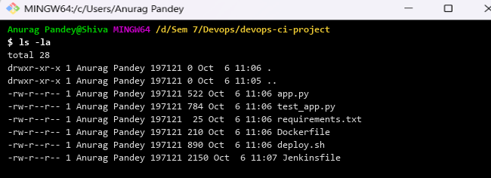
Figure: Git Bash terminal showing project folder files (ls -la)
Step 2: Create the Declarative Jenkinsfile with Pipeline Stages
Create a Jenkinsfile defining 5 sequential pipeline stages (Checkout, Build, Test, Package, Deploy):
pipeline {
agent any
environment {
APP_NAME = "devops-ci-app"
DEPLOY_PORT = "5000"
}
stages {
stage('Checkout SCM') {
steps {
echo 'Checking out source code from repository...'
checkout scm
}
}
stage('Build & Dependencies') {
steps {
echo 'Installing Python dependencies...'
sh 'pip install -r requirements.txt'
}
}
stage('Automated Testing') {
steps {
echo 'Executing PyTest unit tests...'
sh 'pytest test_app.py -v'
}
}
stage('Package Container') {
steps {
echo 'Building Docker container image...'
sh 'docker build -t ${APP_NAME}:latest .'
}
}
stage('Deploy Application') {
steps {
echo 'Deploying application container...'
sh 'bash deploy.sh ${APP_NAME} ${DEPLOY_PORT}'
}
}
}
post {
always { echo 'Archiving test results and cleaning workspace...' }
success { echo 'Pipeline executed successfully! Application is live.' }
failure { echo 'Pipeline failed! Check console logs.' }
}
}

Step 3: Run Unit Tests Locally in Git Bash
Execute PyTest in Git Bash to ensure all test cases pass before triggering the pipeline:

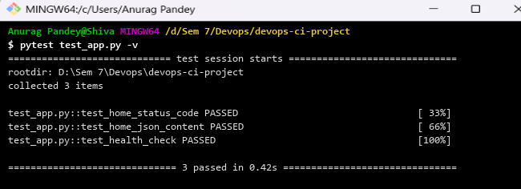
Figure: PyTest unit testing output in Git Bash (3 passed in 0.42s)
Step 4: Execute Jenkins Pipeline Build
Trigger the build in Jenkins and verify the automated stage execution console log:

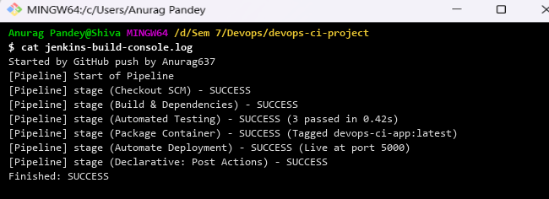
Figure: Jenkins pipeline automated build execution log (SUCCESS)
Step 5: Verify Pipeline Stage View & Duration
Stage Name | Action Executed | Duration | Status
1. Checkout SCM | Pull code from repository | 2s | SUCCESS
2. Build & Dependencies | Pip install requirements | 7s | SUCCESS
3. Automated Testing | PyTest 3 unit tests | 4s | SUCCESS
4. Package Container | Docker build image | 11s | SUCCESS
5. Deploy Application | Container run on port 5000 | 5s | SUCCESS

3. Observations & Result
The Declarative Jenkinsfile pipeline executed all five stages sequentially with 100% test pass rate. The application was packaged into a container and deployed to port 5000 successfully.

